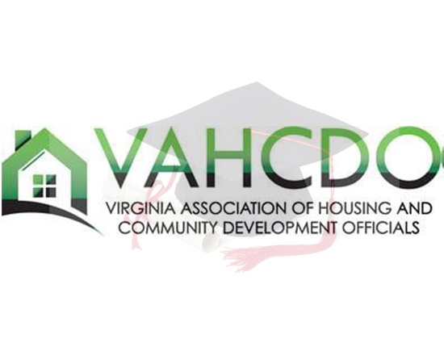
2023 SCHOLARSHIP APPLICATION
The Virginia Association of Housing and Community Development Officials (VAHCDO) 2023 Scholarship Process will open February 1, 2023!

Start preparing now and refer to the VAHCDO Scholarship Program Hints for Students and Agencies (link) for helpful tips!
If you have any questions, please contact:
Wanda Daniel
​Scholarship Chairperson
Richmond Redevelopment and Housing Authority
804.780.4832
Email: wanda.daniel@rrha.com
INSTRUCTIONS AND GENERAL INFORMATION
Instructions for Submitting Applications:

- Complete and sign the attached application form only in the space provided. Any attachment NOT requested, such as a resume, will not be used in evaluating the application.

- The following MUST be submitted with the application:
  - A copy of high school transcripts listing Grade Point Average (GPA) and Class Ranking (MINIMUM 2.5 CUMULATIVE GPA). Note: For those schools that do not have GPA, please provide SAT Scores (MINIMUM of 900).

  - Two (2) SIGNED letters supporting the character, achievements, and potential for education and career advancement of the applicant. One of the letters MUST be from a school official (principal, counselor, teacher, etc.). The other letter must be from a minister, coach, employer, or any person with significant knowledge of the applicant.

  - A SIGNED sponsorship letter from the Executive Director of the Housing Authority in which the applicant resides. Sponsorship requires a commitment on the part of the Authority to support travel expenses (one day). The authority may be required to transport any applicant(s) to a designated location should the applicant be selected for interviewing as one of the finalists. The agency sponsoring the applicant must be an active agency member of the Virginia Association of Housing and Community Development Officials at the time of application and at the time the scholarship award is made. The sponsoring agency must have membership in good standing with SERC and NAHRO in order for the scholar to qualify for additional scholarship opportunities available through those organizations.
General Information:

- Applications and support documents must be received by March 24, 2023. No applications will be accepted by facsimile (fax) transmission. It is the responsibility of the applicant or the Public Housing Authority (PHA) to submit the application form with appropriate transcript and letters as one complete package scanned and emailed to Chairperson. Transcripts or letters mailed directly to the Scholarship Chairperson will not be considered by the Scholarship Committee.

- Scholarship awards will be made to residents of public housing and other assisted housing in the Commonwealth of Virginia who have maintained their residence for six months prior to February 28, 2023.

- All applicants must graduate no later than June 30, 2023.

- Funds are to be utilized beginning with the Fall Semester 2023 school year.

- Finalists and the grantees will be selected by the Scholarship Committee of the Association.

- The scholarship grantees will be announced at the annual meeting of the Association and presented at the Annual Scholarship Luncheon, Thursday, May 11, 2023, at the Sheraton Norfolk Waterside.

- Requests for scholarship funds should be made to Wanda Daniel either by the student or Housing Authority representative. Scholarship funds will be forwarded to the designated Housing Authority representative to be disbursed to the student or will be sent directly to the student. Requests should include a form which identifies the school and lists the student GPA and class schedule to verify full time status.

- The recipient of the award must attend an accredited university, college, vocational, technical, or business school.

- Scholarship recipients will be required to forward a transcript at the end of each semester, to the Scholarship Chairperson or to the housing authority’s Scholarship Committee representative.

- If a scholarship recipient’s family moves out of public or assisted housing after the award has been made, the recipient shall be eligible to continue to receive multi-year funding provided other guidelines are met.

​APPLICATIONS LACKING THE REQUIRED SUPPORTING DOCUMENTS, SIGNATURES, AND/OR APPLICATIONS RECEIVED AFTER March 24, 2023, WILL BE DISQUALIFIED.

